**Determination of Plank’s Constant**

**Experiment No: Date**

**Aim**: To determine the value of Planck’s constant and work function of a material

**Apparatus**: a) Plank’s constant determination apparatus

b) Filters

**Description**:

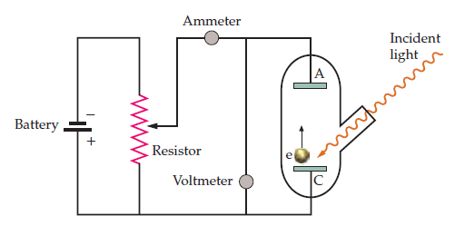

Vs

A schematic diagram of the set up is shown in Fig. 1. When an incident light of photon energy ($hν$) is incident on a metal, photoelectrons are emitted from the metal surface. If the photoelectrons are made to flow between two electrodes having potential difference Vs, the photocurrent stops when the negative voltage applied between the electrodes equals kinetic energy of the photoelectrons.

The basic equation describing photoelectron emission is

$hν=\frac{1}{2}mv^{2}+eϕ$, (1)

Where $h$ Plank is’s constant, $ν$ is the frequency of the incident radiation, m is the mass $,v$ is maximum velocity and e is charge of the electron. $ϕ$ Is the work function of the material of the cathode.

If $V_{s}$ is the retarding or the cut of or stopping voltage where the photoelectron current stops then

$hν=eV_{s}+eϕ$, (2)

Therefore, a graph between the cut off voltage Vs and frequency of the light $ν$ will be a straight line. The slope of the line and intercept with the Y-axis will be $h$ and $ϕ$ respectively.

$$h=e\frac{V_{s}}{Δν}$$

$$ϕ=intercept of the straight line with Y-axis$$

**Procedure**:

1. Connect the instrument to power output.
2. Put the required filter in its place (start from Red and go to Blue filter one by one).
3. Switch on the instrument. Put the knob ‘voltage/Current’ to current measurement)
4. Increase the intensity of the light bulb
5. Note the photocurrent
6. Increase the decelerating voltage by rotating the knob and note the decrease in photocurrent
7. When photocurrent is zero, go to voltage measurement mode and note the voltage
8. Plot the Cut of voltage against the frequency of light

**Observations**:

|  |  |  |  |
| --- | --- | --- | --- |
| **Sl. No** | **Filters** | $$ν (×{10}^{14}/sec)$$ | **Stopping Voltage Vs**  **(Volt)** |
| **1** | **Red ( = 635 nm)** |  |  |
| **2** | **Yellow I (( = 570 nm)** |  |  |
| **3** | **Yellow II ( = 540 nm)** |  |  |
| **4** | **Green (( = 500 nm)** |  |  |
| **5** | **Blue (( = 460 nm)** |  |  |

**Graph**: Plot $ν$ along x and Vs along y –axis in a Graph

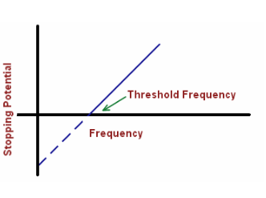

**Calculation**:

**Planck’s Constant**

$h=e\frac{V_{s}}{Δν}$ =1.60210-19

=

**Intercept at $ν=0$**  =

**Work Function** of the material $ϕ$ =

**Error**: Standard value of =6.6110-34 joule sec

Error = $\frac{Standard Value-Measured Value}{Standard Value}×100$

**Conclusion**: With the use of Plank’s constants apparatus, the Plank’s constant has been found to be …………….. with ……..% error.

**Precautions**:

1. The intensity of the light bulb should reach a suitable level
2. The filters should be handled carefully without touching the surface

**Marks Awarded** Signature of the student

|  |  |  |  |
| --- | --- | --- | --- |
| Planning and Execution (2) | Results and Report  (6) | Viva (2) | Total (10) |
|  |  |  |  |

Regd. No:

Group:

Branch:

Signature of the Faculty